FEM term project

Mikko Karkkainen

# Introduction

The static radial, hoop and axial stresses in the geometry shown in Figure 1 resulting from the uniform pressure $p$ are studied using the FEM (finite element method) solver FEM2D.exe. Steady state and plain strain conditions are assumed. The results are compared to the analytical solution.

The pressure $p$ is iteratively chosen so that the maximum stress in the calculation domain matches a critical stress value corresponding to $\frac{52 000}{1.5}$ psi (steel with safety factor of 1.5).

The calculation domain is discretized using 8-noded quadratic (serendipity) elements in a cylindrical coordinate system ($θ, r ,h$). Due to the assumption of plain stress, the length in $h$ direction (through the page) is assumed to be infinite. The mesh is generated using Python. The effect of mesh refinement is studied by varying the number of elements in the radial direction between 1 and 3.

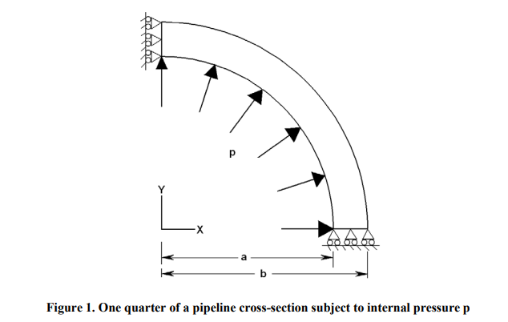

# Methods

The configurations for the model are detailed below.

## Preprocessing

The physical parameters for the calculation are shown in Table 1. The discretization of the calculation domain is done according to Table 2. The boundary conditions are shown in table 3.

Table 1. Physical parameters for all calculation cases.

|  |  |
| --- | --- |
| Young’s modulus | $31⋅{10}^{6}$ psi |
| Poisson’s ratio | $$0.3$$ |
| Inner radius a | $6$ in. |
| Outer radius b | $7$ in. |
| Tensile strength | $52⋅{10}^{3}$ psi |
| Safety factor | 1.5 |
| Critical stress | $34.6667⋅{10}^{3}$ psi |

Table 2. Discretization of calculation domain.

|  |  |  |
| --- | --- | --- |
| Calculation case | Number of elements | |
|  | Axial $(θ)$ | Radial $(r)$ |
| Case A | 10 | 1 |
| Case B | 10 | 2 |
| Case C | 10 | 3 |

Table 3. Boundary conditions for the calculation. $u$ is the displacement in the $x$-direction. $v$ is the displacement in the $y$-direction.

|  |  |
| --- | --- |
| Location | Condition |
| $$θ=0$$ | $$v=0$$ |
| $$θ=\frac{π}{2}$$ | $$u=0$$ |

## Processing

The input file for MESH2D.exe is generated using a python script.

The conversion from cylindrical coordinates to Cartesian coordinates is done in the following way:

$$x=rcos(θ)$$

$$y=rsin(θ)$$

The hoop-wise uniform distributed force vector for an element is given by

$$\left\{F\right\}= \begin{matrix}\frac{1}{6}2Δθr_{i}⋅p \\ \frac{4}{6}2Δθr_{i}⋅p \\ \frac{1}{6}2Δθr_{i}⋅p\end{matrix}$$

These must be converted to Cartesian coordinates for the solver. In the x-direction:

$${\left\{F\right\}}_{u}= \begin{matrix}\frac{1}{6}2Δθr_{i}⋅p cos⁡(θ) \\ \frac{4}{6}2Δθr_{i}⋅p cos⁡(θ) \\ \frac{1}{6}2Δθr_{i}⋅p cos⁡(θ)\end{matrix}$$

In the y=direction:

$${\left\{F\right\}}_{v}= \begin{matrix}\frac{1}{6}2Δθr_{i}⋅p⋅sin⁡(θ) \\ \frac{4}{6}2Δθr_{i}⋅p⋅sin⁡(θ) \\ \frac{1}{6}Δθr_{i}⋅p⋅sin⁡(θ)\end{matrix}$$

## Post Processor

The internal pressure $p$ which results in the maximum stress for the domain equalling the critical stress value is found using bisection. The iteration is stopped when the residual is under 100 psi.

The initial guess is $p=10000$ psi.

The results are analysed using a Python script.

## Analytical Solution

The analytical solutions for the stresses are given below using $r_{o}$ as outer radius, $r_{i}$ as inner radius, as a function of radius $r$.

The analytical solution for radial stress:

$$σ_{r}=\frac{P}{\left(r_{0}^{2}-r_{i}^{2}\right)}\left(r_{i}^{2}-\frac{r_{i}^{2}r_{0}^{2}}{r^{2}}\right)$$

The maximum for $σ_{r}$ is achieved when $r=r_{0}:$

$$σ_{r=r_{0}}=p$$

The analytical solution for hoop stress:

$$σ_{θ}=\frac{P}{\left(r_{o}^{2}-r_{i}^{2}\right)}\left(r_{i}^{2}+\frac{r_{i}^{2}r_{0}^{2}}{r^{2}}\right)$$

The maximum for $σ_{θ}$ is achieved when $r=r_{i}$

$$σ_{θ,r=r_{i}}=\frac{P\left(r_{i}^{2}+r_{o}^{2}\right)}{\left(r_{o}^{2}-r_{i}^{2}\right)}≈6.5385⋅ p$$

The analytical solution for axial stress:

$$σ_{z}=-ν\left(σ_{r}+σ_{θ}\right)=\frac{2ν⋅p⋅r_{i}^{2}}{r_{0}^{2}-r_{i}^{2}}≈1.3846⋅p$$

# Results and Discussion

The value of $p$, which results in a hoop stress within 100 psi of the critical stress $34.6667⋅{10}^{3}$ psi psi is found to be $p=6625$ psi

Results for the FEM and analytical solutions are shown in table 4.

Table 4. Comparison between Analytical and FEM solutions. Units in psi. Negative sign indicates compression, positive tension.

|  |  |  |  |  |
| --- | --- | --- | --- | --- |
| Property | 1 row element | 2 row elements | 3 row elements | Analytical |
| Max Hoop stress | 34760 | 35110 | 35270 | 42300 |
| Max rad. stress | -5209 | -6139 | -6468 | -6625 |
| Max axial stress | -10057.8 | -10360.2 | -10471.02 | -9173 |

# 

# From the results we can see, that the maximum radial stress value converges towards the analytical value well. However, the max hoop stress and max axial stress do not. The result may be improved by refining the mesh further.